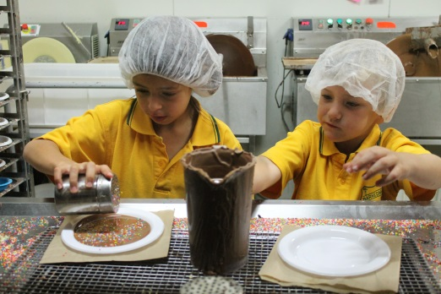
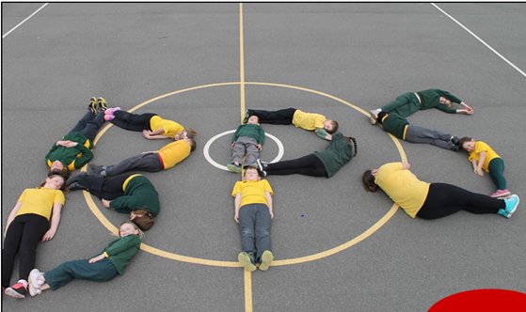
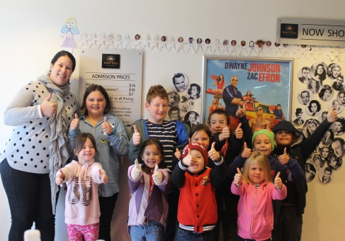
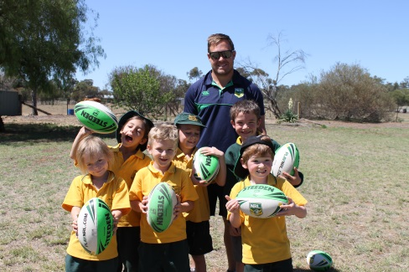
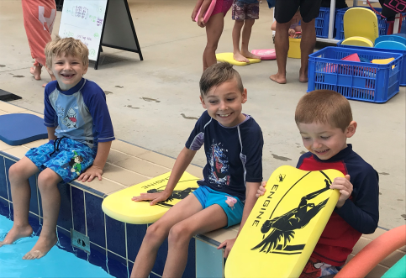
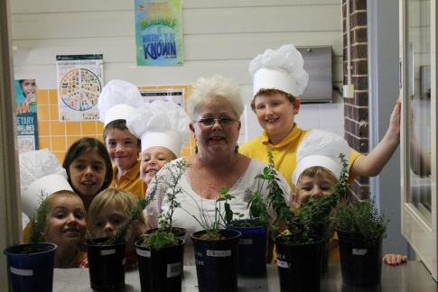
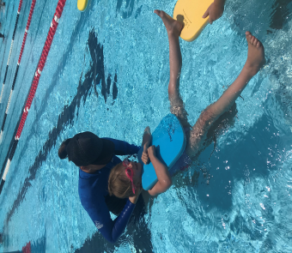
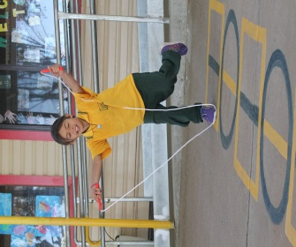
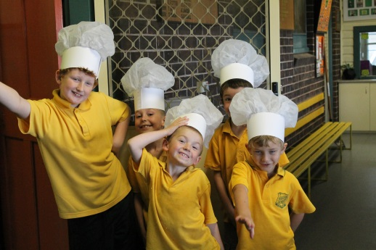
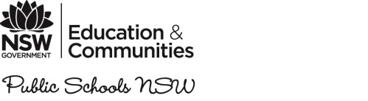
School plan 2018 – 2020
Barmedman Public School - 1137
School background 2018 - 2020

School vision statement |  | School context |  | School planning process
At Barmedman Public School we inspire every student to be driven to excel and achieve beyond their potential, providing a supportive holistic environment which promotes lifelong learning |  | Barmedman Public School is situated in the north of the Riverina Region and is part of the Riverina North West School Education Group. Students that attend the school are from the country village of Barmedman, which has begun to have a more stable number of families with school age children, after having reduced numbers due to the continuous and devastating drought conditions over the past 8 years. We have 6 families with a total of 9 students enrolled for 2018 and 10 students anticipated for 2018.  The school has large historic open buildings comprising of two large spacious classrooms, art room, library, sports shed, large shaded COLA, separate shaded equipment and a refurbished well equipped kitchen all located on well-maintained 5 acre grounds. |  | In 2018, Barmedman Public School staff continue the process of reviewing current practices and started the collaborative process of consulting with parents and community members about the objectives of the current School Plan. We were able to identify, in light of the previous School Plan areas of weakness and improvements that could be made to provide an educationally stimulating environment. As a united staff we continue to collect evidence, including student results, attendance, behaviour and participation, along with survey data from staff, students and parents. This evidence was used to present to parents and community members to help identify the priorities for the 2018-2020 School Plan.  This process included a review of the strengths, opportunities and areas for development across the School. As a result, three key strategic directions were identified as a basis for a shared commitment to future developments across the School.  These are:  - Student Learning and Engagement  - Excellence in Staff Teaching and Learning  The School Plan 2018-2020 sets clear improvement measures and forms the basis for the school’s improvement and development efforts. This, together with parents and community members will help strengthen the commitment we have in providing every child with the opportunity for the best start in life.

School strategic directions 2018 - 2020

STRATEGIC DIRECTION 2

Excellence in Staff Teaching and Learning
STRATEGIC DIRECTION 1

Student Learning and Engagement

Purpose:  To ensure students are achieving personal learning goals for effective differentiation, continuous monitoring and feedback and appropriate intervention programs. |  | Purpose:  We aim to deliver quality teaching in every classroom, every day to ensure educational delivery is consistent, of a high standard, to inspire lifelong learners.

Strategic Direction 1: Student Learning and Engagement

Purpose |  | People |  | Processes |  | Practices and Products
To ensure students are achieving personal learning goals for effective differentiation, continuous monitoring and feedback and appropriate intervention programs. |  | Students: Students development a growth mindset as successful, active and engaged learners to achieve their full potential in Literacy and Numeracy.  Students: Access other learning opportunities through broader learning experiences to provide a real world context.  Staff: Will maximise student learning through identifying and analysing data (SMART, attendance, Learning Progressions etc) to plan and target explicit individualised, integrated and differentiated learning.  Parents: Will collaboratively develop and support their child in the implementation and monitoring of PLP’s, ensuring their child’s engagement, wellbeing and aspirations are met.  Community Partners: Work collaboratively with school staff to support student achievement in learning, engagement and wellbeing. |  | Curriculum and Learning  Students are engaged in differentiated and authentic learning experiences that foster creativity, communication, timely feedback which fosters their wellbeing.  Assessment, planning and programming and teaching models inform and improve student learning outcomes.  Personalised Learning  Staff use rigorous identification and monitoring processes to ensure high levels of support are provided for identified students.  Interventions are provided for students ‘at risk’ and involve integrated and intensive support in literacy and numeracy. These interventions include: L3, TEN and is supported through EAfS.  Evaluation plan:  Staff will lead inquiry discussions analysis around:  - Literacy and Numeracy (Learning Progressions) Data  - NAPLAN Data  - Student Attendance  - Student behaviour and engagement  - Current Intervention Programs  - Teaching and Learning Programs  - Assessment and Reporting Processes  - Extra-Curricular Programs |  | Practices  Students are involved in reflective assessment and reporting processes. (SMART GOALS)  Every student is actively engaged in learning to their year level.  Learning across the school will be driven by assessment data and differentiated to meet the needs of all students. This will be evident in classroom practice, programming and reporting.  Products  Positive and respectful relationships provide a productive learning environment, increasing positive behaviour and effective engagement.  Evidence of learning will be demonstrated through classroom practice, programming and reporting.
Improvement Measures
- Increase the proportion of students achieving proficiency in line with the Premier’s Priorities

- Students will achieve growth in
Literacy and Numeracy

Strategic Direction 2: Excellence in Staff Teaching and Learning

Purpose |  | People |  | Processes |  | Practices and Products
We aim to deliver quality teaching in every classroom, every day to ensure educational delivery is consistent, of a high standard, to inspire lifelong learners. |  | Students: Will provide timely and respectful feedback to teachers on their learning experiences.  Staff: Will maintain accurate records, documentation and assessment data in order to evaluate and adjust their teaching strategies, to maximise impact on student learning.  Staff: Will implement targeted professional learning programs designed to develop leadership, management & excellence using the Teaching Standards and School Excellence Framework.  Leaders: Will establish and improve processes which build the capacity of the school community.  Leaders: Expand professional learning opportunities for all staff that focus on improved student learning.  Parents: Will be more engaged in creating a collaborative approach to educating the whole child in all areas through an increased participation in school programs. |  | EaFS  Embed the EAfS initiative and drawn upon its professional learning opportunities in literacy and numeracy to enhance teaching practices (e.g. L3, TEN).  Evaluative Practice  Data, including Learning Progressions, is updated and monitored to inform teaching and plan for learning.  Leaders will build a culture of high expectations for quality teaching.  Evaluation plan:  Staff will lead inquiry discussions analysis around:  - Practice Analysis Conversation  - Review of Teaching and Learning Programs  - Early Action for Success Program  - Professional Development Framework / SEF v2  - Learning Conferences  - Learning Progressions and NAPLAN Data  - Classroom Observations  - Achievements of PDP’s goals  - Analysis of IEP’s |  | Practices  Continuous collaboration and reflection of learning results to inform explicit teaching approaches to literacy and numeracy.  Teachers demonstrate and share expertise of content knowledge and teaching practice.  Products  Teaching and Learning Programs across the school show evidence that they are adjusted to address individual student needs, ensuring that all students are challenged and that all adjustments lead to improved learning.  The school has embedded explicit systems for collaboration, classroom observation and feedback to drive school-wide improvement in teaching practice and improving student outcomes.
Improvement Measures
- All Teachers will analyse school based data to plan and implement a differentiated curriculum in Literacy and Numeracy.

- All Staff professional increase the number of learning experiences as evidence in all teaching programs.

